**Assignment - 2**

|  |  |
| --- | --- |
| Student Name | GAYATHRI MJ |
| College Roll Number | 19TUCS041 |
| Maximum Marks | 2 |

1)SALES BY CUSTOMER

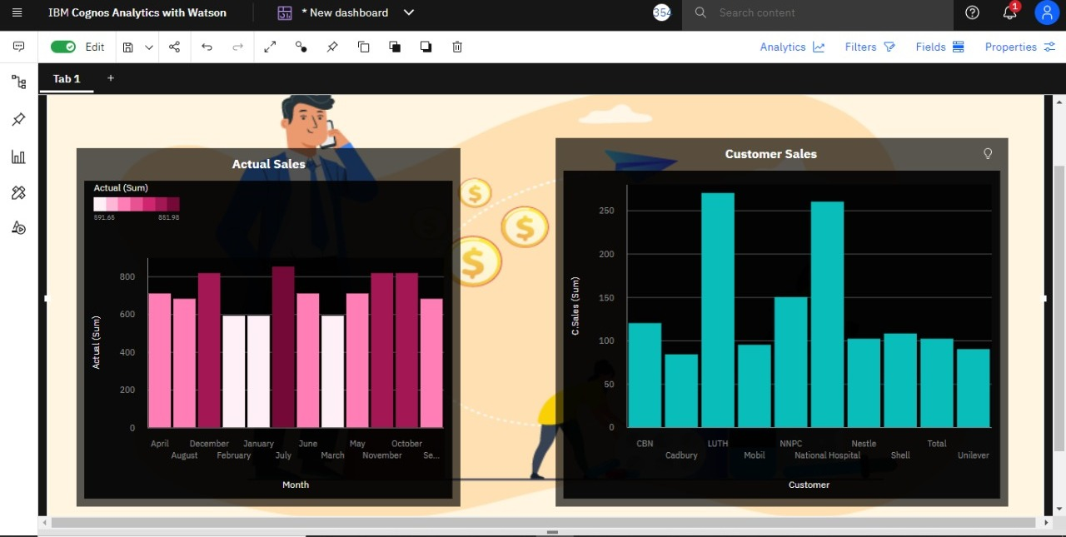

2)SALES BY LOCATION

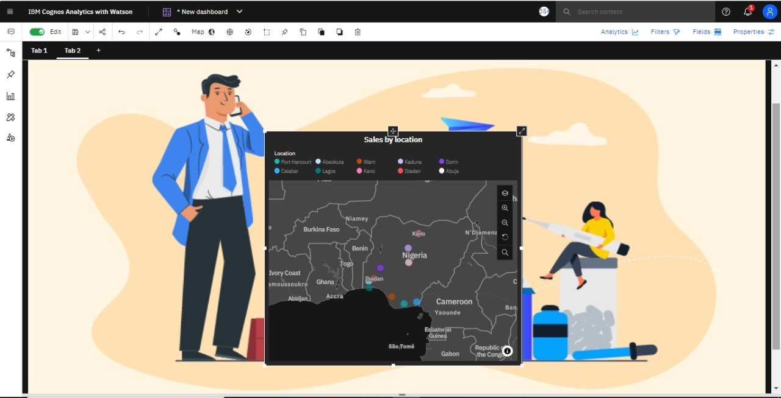

3)SALES BY SALES REPRESENTATIVE

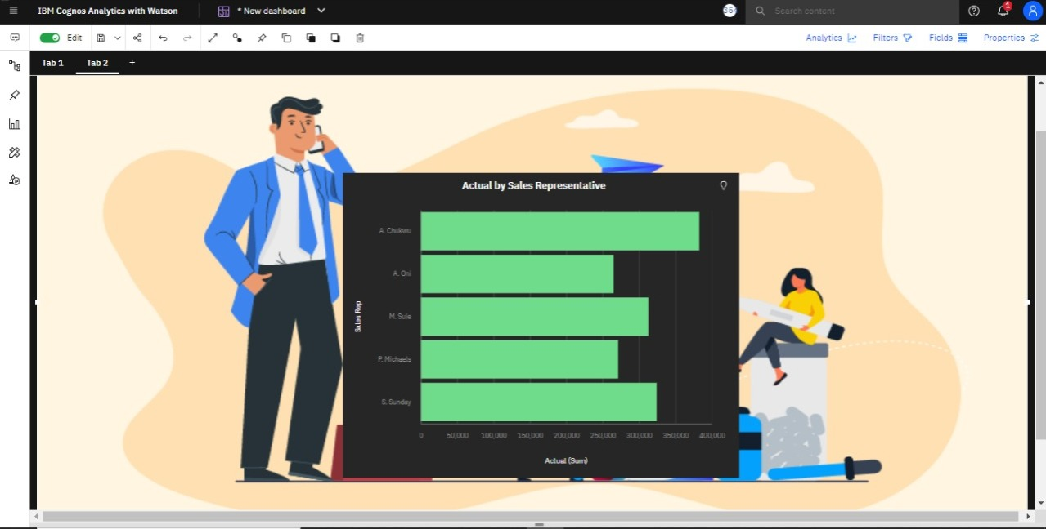

4)RECEIVED INVENTORY FROM SUPPLIER

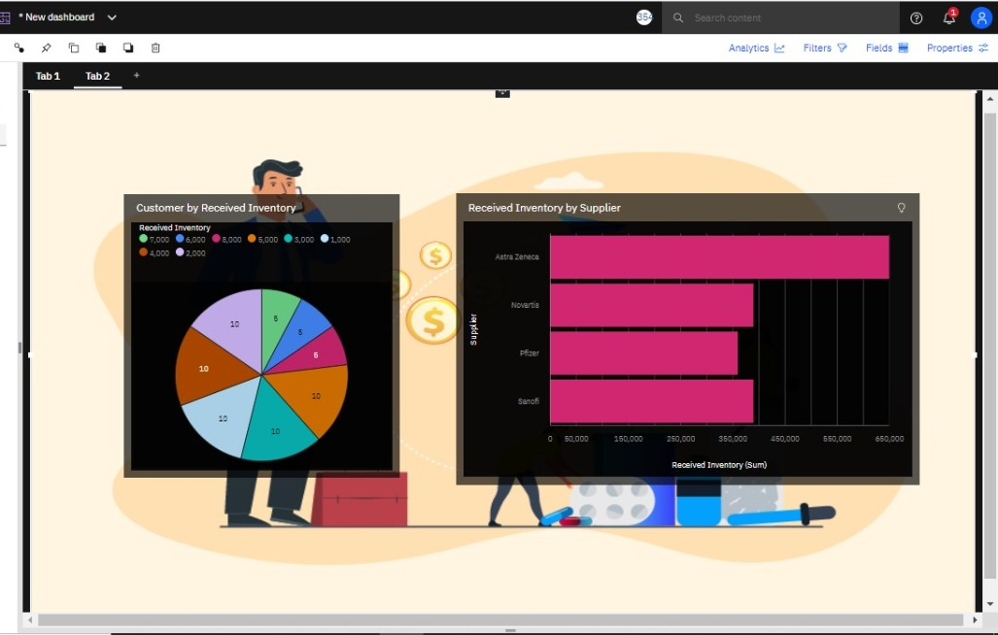

5)INVENTORY STOCK FOR WAREHOUSE LOCATIONS

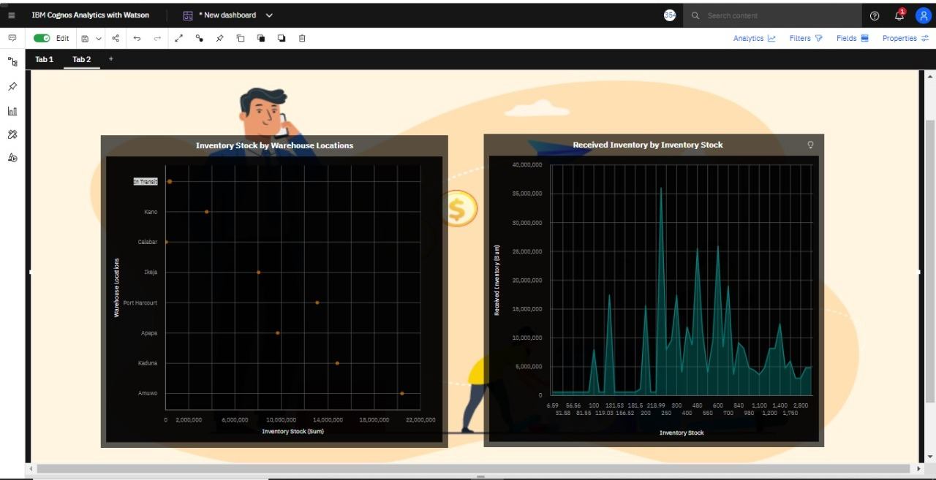

6)SALES TREND

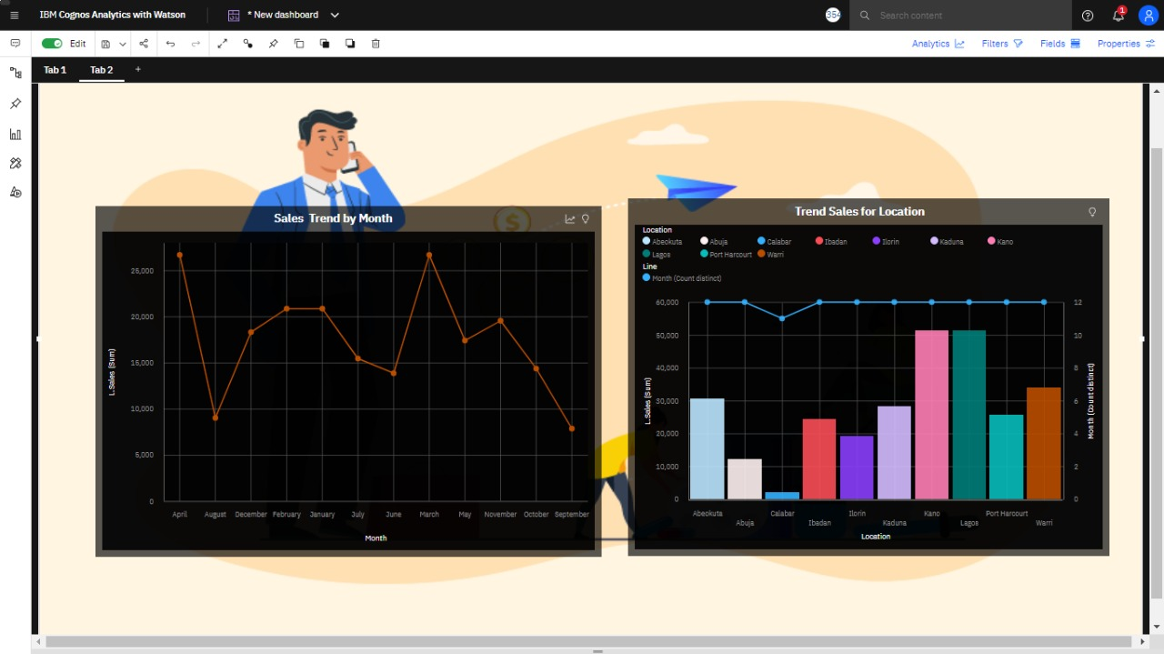

7)MONTHLY SALES

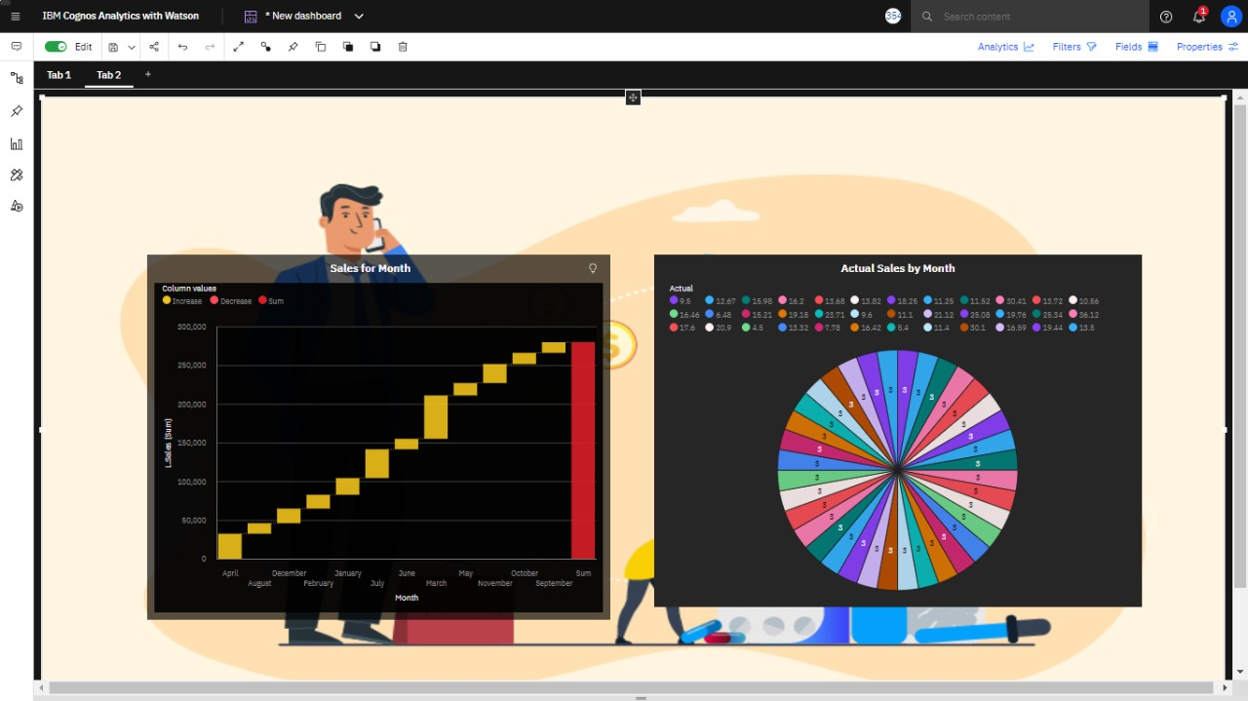

8)ACTUAL AND RECEIVED INVENTORY BY MONTH

